Project Management Plan (PMP)
for Non-Contact Type Clinical Thermometer for Adult People

Part Number: 24-06-TRM-800
Rev: 03
Date: 8 Oct 2024

FIRST RELEASE
CREATED BY
Name | School Number | Title | Date Sign.
ELİF AĞILLAR | 20290377 | Program Mng | 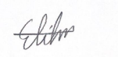  13.10.2024
APPROVED BY
Name | School Number | Title | Date Sign.
DOĞA ERPAK | 20290411 | QA Engineer |   13.10.2024
BETÜL CAN | 20290396 | System Design Engineer | 13.10.2024 
BEYZA YAŞAR | 20290441 | 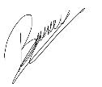  Electronic Design Engineer 13.10.2024
FATİH ÜNAL | 16290805 | 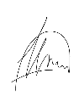  Mechanical Design Engineer 13.10.2024
FAHRİYE ÖZGE DEMİRTAŞ | 20290403 | Production Engineer |   13.10.2024
NİSA BAŞAK | 20290392 | Software Engineer |   13.10.2024

Rev. No Change Description DAte QA Approval
01 Job Description, Responsibilities 04.11.2024 Approved
02 Subtext correction, Table name addition, Project plan change 19.11.2024 Approved
03 Amendments in responsibilities part 30.11.2024 Approved

TABLE OF CONTENTS
change records 2
fırst release 2
REVISIONS 2
1. PURPOSE 5
2. SCOPE 5
3. REFERENCES 5
4. RESOURCES 6
5. TEAM ORGANIZATION, RESPONSIBILITIES, COMMUNICATION 6
5.1. ORGANIZATION CHART 7
5.2. JOB DESCRIPTIONS, RESPONSIBILITIES 7
5.2.1. Program Engineer 7
5.2.2. System Engineer 8
5.2.3. Electronics Engineer 8
5.2.4. Mechanical Engineer 9
5.2.5. Production Engineer 9
5.2.6. software Engineer 9
5.2.7. Quality Assurance Engineer 10
5.3. COMMUNICATION 10
6. WORK BREAKDOWN STRUCTURE (WBS) 11
6.1. PLANNING 13
6.1.1. REQUIREMENTS CAPTURE 13
6.1.2. Project Management Plan 13
6.2. desıgn phase (conceptual/detaıled desıgn) 14
6.2.1. preliminary design (conceptual design) 14
6.2.2. detailed design 14
6.2.3. research for epidermal thermal response 15
6.3. ımplementatıon 16
6.3.1. prototype production 16
6.3.2. verıfıcatıon/valıdatıon 17
6.4. SUPPORTING PROCESSES 17
6.4.1. Qualıty ASSURANCE 17
6.4.2. RISK MANAGEMENT 17
6.4.3. PROCUREMENT 18
6.4.4. CONFIGURATION MANAGEMENT 18
6.4.5. DESING REVIEWS 19
7. Schedule 20

PURPOSE
This document is created to provide the necessary information for the execution of a non contact type clinical body thermometer design project. It states how and when the project's objectives are to be achieved, by showing the major products, milestones, activities, resources and responsibilities required on the project.

SCOPE
The object of this project is to design a clinical thermometer for body temperature measurement satisfying the basic safety and essential performance requirements of ISO 80601-2-56:2017. All activities will be executed by 4-year students with the help of university academic staff and the project shall be finalized within 2 semesters.
A prototype will be manufactured in the scope of this project using the detailed design data and verified/validated according to the inspection/test procedures written by the design group.
Requirements standards may be used during the requirements capture process to define the rules, procedures, methods, guidance, and criteria for developing the requirements. Requirements standards include methods, and qualification tests which will ease the verification, validation, and certification.

REFERENCES
  - EN ISO 80601-2-56-2017: Particular requirements for basic safety and essential performance of clinical thermometers for body temperature measurement
  - IEC 60601–1:2005+A1:2012: Medical electrical equipment - Part 1: General requirements for basic safety and essential performance
  - ISO 9001: Quality management systems - Requirements
  - IEC 60601‐1‐2:2014: Medical electrical equipment — Part 1-2: General requirements for basic safety and essential performance — Collateral Standard: Electromagnetic disturbances Requirements and tests
  - ISO 14159: Safety of machinery — Hygiene requirements for the design of machinery
  - ISO 14971: Medical devices – Application of risk management to medical devices
  - IEC 60601‐1‐2:2014: Medical electrical equipment — Part 1-2: General requirements for basic safety and essential performance — Collateral Standard: Electromagnetic disturbances — Requirements and tests.
  - IEC 60601‐1‐6:2010+A1:2013: Medical electrical equipment — Part 1-6: General requirements for basic safety and essential performance — Collateral Standard: Usability +Amendment 1:2013
  - IEC 60601‐1‐11:2015: Medical electrical equipment — Part 1-11: General requirements for basic safety and essential performance — Collateral Standard: Requirements for medical electrical equipment and medical electrical systems used in the home healthcare environment
  - IEC 60601‐1‐12:2014: Medical electrical equipment — Part 1-12: General requirements for basic safety and essential performance — Collateral Standard: Requirements for medical electrical equipment and medical electrical systems intended for use in the emergency medical services environment
  - ISO 15223‐1:2016: Medical devices — Symbols to be used with medical device labels, labeling and information to be supplied — Part 1: General requirements
  - IEC 62366‐1:2015: Medical devices — Part 1: Application of usability engineering to medical devices
  - IEC 60086-4, Primary batteries – Part 4: Safety of lithium batteries

RESOURCES
As human resources, 7 engineering students are expected to be sufficient to successfully realize the project. Engineering students will be responsible for different tasks; like electronic design, prototype production, program management, etc. The allocation of labor is stated in the “job descriptions, responsibilities” section of this document. When necessary, allocation will be adjusted during the workflow.
The students have sufficient background and the required capability to carry out the project. They are expected to further improve their skills through the project.
The offices, and laboratories with equipment like DMM, soldering iron, oscilloscope, power supplies etc will be open to the students as working areas. Other facilities and tools like 3D printers, hand tools, photocopy machines, office equipment, software, and necessary standards will also be provided by the university.
Two semesters are expected to complete the project. At least one working prototype of a clinical body thermometer is manufactured and tested for verification/validation and documented.
The money for materials, components, and services is met by students.

TEAM ORGANIZATION, RESPONSIBILITIES, COMMUNICATION
Project teams constitute 7 students selected for different tasks. Job descriptions and responsibilities are given in the following paragraphs.

ORGANIZATION CHART
Program
Mng
Elif Ağıllar

System Eng
Betül Can
Production Eng
Özge Demirtaş
Software Eng
Nisa Başak
QA Eng
Doğa Erpak

Electronics Eng
Beyza Yaşar
Mechanical Eng
Fatih Ünal

JOB DESCRIPTIONS, RESPONSIBILITIES

Program Engineer
- Prepares the project management plan, focusing on scheduling, financing, resources, milestones, reviews, and Earned Value Analysis (EVA).
- Monitors and documents program objectives according to the project plan via design reviews.
- Manages scheduling and execution of programs while addressing cost, schedule, and quality issues.
- Tracks potential risks and updates risk management files accordingly.
- Organizes review meetings and prepares comprehensive review reports at various program milestones.
- Ensures all program documentation is maintained and audit-ready.
- Measures work performed beyond expected cost and schedule using EVA.
- Acts as the communication bridge between management and team members.
- Collaborates with the team to eliminate procurement, testing, and manufacturing constraints, including issues with cost, workshare, equipment, tooling, and facilities.
- Resolves non-conformances in cooperation with design engineers, quality, production, and procurement teams and contributes to Material Review Board (MRB) meetings.
- Prepares monthly reports
- Preliminary/Critical Design Reviews

System Engineer
- Collaborates with the Program Engineer to develop the project management plan.
- Leads design reviews and presents comprehensive design data.
- Prepares risk management files for potential risks in the project.
- Creates and documents conceptual design elements, such as "Requirement Specifications," "Design Descriptions," and "Configuration Item Lists."
- Investigates epidermal electronic devices, skin systems, and human body thermoregulation to assist electronic and software engineers with temperature calculations.
- Establishes electrical, mechanical, and user interfaces for the system.
- Develops system block diagrams that detail all configuration items and their interfaces.
- Ensures design documents are complete and accurate.
- Prepares Thermometer Assembly document

Electronics Engineer
- Collaborates with the System Engineer to prepare conceptual design documents such as "Requirement Specifications," "Design Descriptions," and "Configuration Item Lists."
- Simulates electronic circuits using software tools like Proteus, TINA, and Electronic Workbench.
- Conducts breadboard trials for electronic circuits.
- Designs electronic circuits, creates schematics, and prepares printed circuit board layouts when necessary.
- Develop system software (firmware).
- Provides mechanical interfaces of electronic hardware to the Mechanical Engineer.
- Recommends measurement methods for hardware testing.
- Prepares electronic hardware engineering drawings.
- Purchasing and kitting (material preparations, tinning, receiving inspection and test)

Mechanical Engineer
- Collaborates with the System Engineer on conceptual design tasks and documents, including "Requirement Specifications," "Design Descriptions," and "Configuration Item Lists."
- Designs mechanical parts (e.g., housing, battery compartments, probe tips) using 3D CAD software, ensuring compatibility with other components.
- Considers installation and uninstallation processes when designing parts.
- Utilizes 3D printing for rapid prototyping of mechanical components.
- Investigates epidermal electronic devices, skin systems, and human body thermoregulation to assist temperature calculations with the Electronic and Software Engineers.
- Designs and manufactures tools and accessories as needed.
- Provides technical drawings to other engineers for documentation or presentation purposes.
- Makes the top assembly production

Production Engineer
- Produces electronic circuit boards, including soldering, bonding, cleaning, and marking processes.
- Assembles cables by stripping, soldering, potting, crimping, and performing continuity tests.
- Manufactures assemblies, adhering to configuration control and tracking as-planned and as-built logs.
- Ensures assemblies are built to the latest revisions and meet manufacturability standards.
- Conducts manufacturing tests, continuity tests, and acceptance tests.
- Prepares manufacturing instructions when necessary.
- Collaborates with the Mechanical Engineer to produce 3D-printed parts.
- Works with the Procurement Engineer to manufacture blackbody sources and thermal baths for tests.
- Prepares the purchased part documents (datasheets or creating new documents)

Software Engineer
- Collaborates with the System Engineer to prepare conceptual design documents such as "Requirement Specifications," "Design Descriptions," and "Configuration Item Lists."
- Develop system software (firmware) for the project.
- Works with the Electronic Engineer to integrate software with designed electronic circuits.
- Designs and implements algorithms for data acquisition, processing, and control.
- Investigates human body thermoregulation and collaborates with Electronic and Mechanical Engineers for temperature-related calculations.
- Simulates software behaviors using tools or frameworks specific to the system requirements.
- Conducts software testing to ensure system reliability and robustness.
- Prepares user interfaces or interaction modules as required for the system.
- Documents software architecture, development processes, and testing protocols for audit and future reference.
- Prepares verification and validation test procedures.

Quality Assurance Engineer
- Review requirements, technical specifications, and design documents for approval.
- Supports the design, development, and enhancement of test processes.
- Prepares and approves detailed verification and validation test plans.
- Documents inspection and test results, offering recommendations for improvements based on analysis.
- Collaborates with the design team to address bugs and non-conformances.
- Conducts audits to ensure all processes comply with the project plan and applicable standards.
- Ensures all test and measurement devices are properly calibrated.
- Leads the Material Review Board (MRB) to address non-conforming materials.
- Tracks corrective actions taken to resolve issues and improve processes.
- Prepares the Acceptance Test Procedure (ATP)

COMMUNICATION
Communication may be carried out by e-mail for formal communication like meeting calls, technical information exchange, document transfer, or through phone conversations for urgent cases. E-mails and phone numbers are given below. E-mails will be preferred since most of them can be used as input to the project records.

Job Name E-mail Phone Number
Program ELİF AĞILLAR eliff.agillar@gmail.com 05071002006
System Design BETÜL CAN betulcan1705@gmail.com 05534443660
Electronics Design BEYZA YAŞAR beyzanuryasar87@gmail.com 05417165349
Mechanical Design FATİH ÜNAL business@ftunal.com 05330433506
Quality Assurance DOĞA ERPAK erpakdoga@gmail.com 05523522244
Production F.ÖZGE DEMİRTAŞ f.ozge.demirtas@gmail.com 05319247157
Software NİSA BAŞAK nisabasak603@gmail.com 05517031738

WORK BREAKDOWN STRUCTURE (WBS)
The object, hence the output of this project is the design data (Technical Data Package) of the Clinical Body Thermometer. The structure of WBS with its work packages and expected work hours is given in Figure 1 and a description of work packages is given in the following paragraphs.
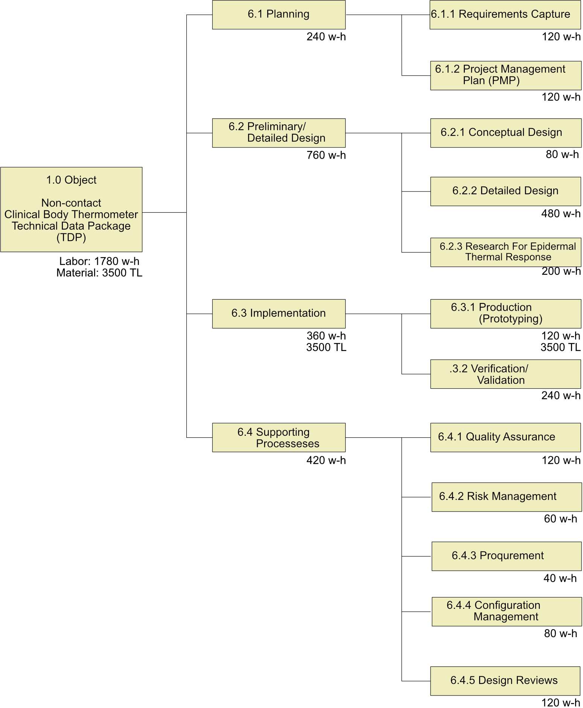
Figure-1: Work Breakdown Structure of designing a non-contact clinical body thermometer

PLANNING

REQUIREMENTS CAPTURE
Process inputs: Standards in the “References” section, customer expectations
Process outputs: “Requirements Specification” document
Requirements specify the functional, performance, safety, quality, maintainability, and reliability requirements as well as disposal of waste products at the end of their expected service life, and effects on public health if any.
Requirements for basic safety and essential performance are identified, defined, and documented. This includes choice of technology, the basic and optional functionality, environmental, and performance requirements as well as the requirements imposed by the system safety assessment. These may include built-in tests, testability, external interfaces, environment, test and maintenance considerations, power, and physical characteristics.
Statutory and regulatory requirements related to the product shall be defined, especially for certification purposes.
The instructions for use shall provide advice on the proper disposal of waste products, residues, etc. And of the equipment and accessories at the end of their expected service life.
If a thermometer is designed as a part of a patient's diagnostic or observation system, the system requirements allocated to the hardware item should be documented also.
The standards in the “References” section may be used during the requirements capture process to define the rules, procedures, methods, guidance, and criteria for developing the requirements. Requirements standards may include methods, qualification/test, manufacturing, and workmanship which will ease the verification, validation, and certification.
The requirements document will be checked at the preliminary design review meeting if;
- Each requirement is unambiguous, verifiable, and described in complete enough detail and should not conflict with other requirements.
- Applicable standards and guidance are considered?
- All hardware functions and interfaces are covered?

project management plan
Process inputs: Requirements Specification
Process outputs: “Project Management Plan” document
The design life cycle processes (Defining Requirements, Conceptual Design, Detailed Design, and Implementation) are clearly defined in this Project Management Plan including the activities, milestones, risk assessment, inputs, outputs, and responsibilities.
Standards for design processes are selected and defined in the plan.
Responsibilities for supporting processes are also defined for a smooth transition between the phases and to assure product quality, reliability, and safety.

desıgn phase (conceptual/detaıled desıgn)
The design phase includes mainly two work packages; a Preliminary Design showing the basic configuration items and their relations and a Detailed Design consisting of the final design of all assemblies, software, discrete parts, and their tests.

preliminary design (conceptual design)
Process inputs: “Requirement Specification” document
Process outputs: “Design Description”, “Configuration Item List” documents and Preliminary Design Review meeting report
The Preliminary Design process produces a high-level design concept to meet the requirements. The input to this process is Requirement Specification.
Preliminary Design can be accomplished using functional block diagrams, design and architecture descriptions, and circuit card assembly outlines. A high-level description should be generated for the hardware item. This will include architectural constraints, component over-stress, reliability, usability, safety, and constraints on software or other system components. Configuration Items and major components should be identified at this stage.
Change control for the configuration items should be started when they are defined. To be able to track the changes, each configuration item shall have an item Part Number to establish a baseline.
At this phase, specific research studies may be performed to have the necessary design documentation. To do this, breadboard designs may be done, simulation tools may be used.
When everything is ready to start to detailed design, a Preliminary Design Review will be realized to review the records, documents, and plans if all planned tasks are completed.
The outputs from this process are the Design Description, Configuration Item List, and Preliminary Design Review meeting report.

detailed design
Process inputs: “Design Description”, and “Configuration Item List” documents
Process outputs: Assembly documents containing circuit schematics, component placement, Bill of Materials (BOM), CAD/CAM files (Gerber, STL, etc.), working baseboard level prototype thermometer, Critical Design Review meeting report, draft system software
The inputs to this process are Requirement Specification, Design Description, Configuration Item List, and Preliminary Design Review meeting report.
Detailed electrical interfaces, mechanical interfaces software interfaces, and user interfaces shall be defined and documented on assembly documents. Schematics of electronic assemblies are designed using electronic design automation software (EDA software like Orcad, eagle, Altium). Mechanical parts are designed with the help of Computer Aided Design (CAD) programs (like Pro-engineer, Solidworks, Catia, Inventor). The operation of electronic boards and mechanical parts/assemblies designed can be verified with simulation tools.
The materials required for detailed design were procured, inspected/tested, and datasheets obtained. The information in datasheets is very important in design work.
Easy installation and dis-installation, part (e.g battery) replacement, ergonomy, and safety shall be considered when designing the mechanical parts and electronic circuits.
Necessary manufacturing files to manufacture the parts in-house or to order shall be created both for Printed Circuit Boards and mechanical parts like Gerber Files, and STL files. Mechanical parts are preferred to be manufactured by a 3D printer in-house.
Tests and other inspection activities shall be performed for each assembly to verify compliance with the requirements.
A brassboard level prototype shall be produced and draft system software shall be coded during this design phase.
Note: Brassboard level prototype is a near-final design circuit, built in a configuration that is representative of the final project, using similar construction methods and materials as the final project. It is between breadboard level prototype and engineering prototype where an engineering prototype is fully representative of the final product using approved components and suitable for a complete evaluation of form, design, and performance.
Documents including engineering drawings, bill of materials (BOM), component specifications, test procedures shall be prepared, and change control activities shall be started for each new document.
A critical Design Review will be performed on this design documentation.

research for epidermal thermal response
Process inputs: Working brassboard level thermometer, draft system software
Process outputs: Final system software, a white paper documenting the research results
The most challenging aspect of thermometer design is the thermal response of skin and part of the thermometer contacting the body, especially for contact-type thermometers. Although it is difficult to find sufficient data in the literature, investigations shall be made on the Internet and printed publications on this subject. If sufficient information can not be obtained from the literature, research will be realized to obtain the necessary data to use in the calculations performed by microcontrollers enabling them to display the correct body temperature.
The scope of work in this regard is limited with measurements in different ambient temperatures. The data including ambient temperature measured with a reference thermometer, measuring site temperature, and reference body site temperature measured both by prototype thermometer and a reference clinical thermometer is collected. Data is analyzed, a correlation is established between ambient temperature and body temperature, and a correction is made to the formula used in the software.

ımplementatıon
After the successful completion of the Critical Design Review, the implementation process will be started using the documents prepared during the detailed design phase to produce the hardware item (Engineering Prototype)
This phase consists of the production of an engineering prototype and qualification tests run on this prototype.

prototype production
Process inputs: Assembly documents containing circuit schematics, component placement, Bill of Materials (BOM), CAD/CAM files (Gerber, STL, etc.), working brassboard level thermometer, Critical Design Review meeting report, draft system software
Process outputs: Engineering Prototype which the verification/validation activities conducted with
An engineering prototype will be built using engineering drawings prepared during the detailed design process. The inputs to this process are assembly/part drawings including Bill Of Material (BOM), CAD files, and Critical Design Review meeting report.
Missing parts are procured from suppliers or manufactured in-house and the installation will start with the guidance of experienced engineers. Installation instructions will be created during the production and the drawings may be revised due to these instructions if necessary.
When required, special test setups may be established for assemblies and sub-assemblies during the production of the thermometer. The non-conformances will be documented and necessary corrective actions will be taken before proceeding.
An Acceptance Test Procedure will be created for the finished product to use before and during the Verification/Validation. The prototype production is completed only when the prototype passes the acceptance test successfully.

verıfıcatıon/valıdatıon
Process inputs: Engineering Prototype with final system software, verification, and validation test plans
Process outputs: Verification/validation report, Technical Data Package
The acceptance test is not intended to verify all requirements. Requirements that are not verified at the acceptance test will be verified during the Verification Process.
Verification consists of reviews, analyses, and laboratory tests (including the acceptance test) applied as defined in the Qualification Plan. The verification process should include an assessment of the results. After successful completion of verification, Validation processes in the field shall be applied to ensure that the requirements are correct and complete for the intended use.

SUPPORTING PROCESSES

Qualıty ASSURANCE
Process inputs: Process Management Plan, verification, and validation test plans
Process outputs: Problem/Corrective Action Reports, MRB records, Audit records
Quality/Process assurance ensures that the life cycle process objectives are met activities have been completed as outlined in plans or that deviations have been addressed.
Hardware design problems, process non-compliance with hardware plans and standards, and deficiencies in hardware life cycle data will be identified, documented, and resolved by means of the Problem Reports. The purpose of problem reporting, tracking, and corrective action is to record problems and ensure correct disposition and resolution. Problems may include non-compliance with plans and standards, deficiencies of life cycle process outputs, anomalous behavior of products, and inadequacy or deficiency of tools and technology processes.

RISK MANAGEMENT
Process inputs: Safety requirements, schedule, resources, budget
Process outputs: Risk Management Files
Responsibility: Program Engineer
The potential risks associated with harm to people and damage to property or the environment like the threat of human errors (usability), and wrong measurements are identified with the collective work of team members and defined at the end of the conceptual design phase.
Once risks have been identified, they must then be assessed as to their potential severity of impact (generally a negative impact, such as damage or loss) and the probability of occurrence. For each potential risk, a risk management file is created to track the status of the risk. The risk management file contains the description of the risk, its impact, probability of occurrence, and the actions to mitigate the risk to an acceptable level.
The risk management files are kept by the program engineer as evidence of an acceptable risk management process, required by most regulatory bodies.
The analysis in this project shall consider the risks of changing environmental conditions for the clinical thermometer and provide guidance regarding the residual risks in the instruction for use.
Also Hygiene risks to the consumer are important, especially for contact-type thermometers, and shall be included in risk management files.

PROCUREMENT
Process inputs: Configuration Item List, BOM, schedule, resources, budget
Process outputs: Orders, components, nonconforming materials
Responsibility: Electronics Engineer
The procurements need to remain within the expenditure budget.
All records need to be kept for each order and must be kept in the correct auditable manner.
Procurements should be consistent with ethics and social responsibility and best practices and adherence to all laws and regulations is a strict requirement. The selection of the vendor depends on the cost and delivery time.
Risk analysis should be made especially for the materials supplied from abroad for delivery time.
The material supplied shall be inspected and or tested for identification and hazards.

CONFIGURATION MANAGEMENT
Process inputs: Configuration Baseline, engineering changes
Process outputs: Change orders, Revised Documents
Responsibility: Production Engineer
The configuration management process is intended to provide the ability to consistently replicate the configuration item, regenerate the information if necessary, and modify the configuration item in a controlled fashion if modification is necessary.
Configuration items should be uniquely identified (e.g. part number), documented, and controlled and baselines should be established at the end of the Conceptual Design phase as the “Configuration Item List” document. The purpose of baseline establishment is to define a basis for further activities and allow reference to, control of, and traceability between configuration items.
Intermediate baselines may be established to aid in controlling hardware activities. Once a baseline is established it should be subject to change control procedures.
The purpose of the change control activity is to ensure the recording, evaluation, resolution, and approval of changes. Change control should be started no later than the establishment of the baseline. Each change shall be recorded with its revision number, described on related documents, and approved by the quality assurance and program engineer.

DESIGN REVIEWS
Process inputs for PMR: “Design Description”, “Configuration Item List”, “Requirement Specification”
Process inputs for CMR: Assembly documents CAD/CAM files working brass board level thermometer, Critical Design Review meeting report, draft system software
Process outputs: PMR, CMR reports
Responsibility: Program Engineer
Design reviews should be performed and documented as review reports, multiple times during the project to determine that the design documents and implementation satisfy the requirements. All Project team members contribute to design reviews.
At least; the Preliminary Design Review is performed at the end of the conceptual design and the Critical Design Review is performed when the detailed design with its design data is completed. Additional reviews may be carried out if necessary. Design reviews will check at least the following.
Minimum design data which shall be ready at Preliminary Design Review are;
- System Requirement Specification document
- Design Description document
- Configuration Item List document
Minimum design data which shall be ready at Critical Design Review are;
- Drawings for configuration items (schematics, layouts, assembly documents, solid model of designed parts, Bill Of Materials, system software)
- Working breadboard-level thermometer
- Test/inspection results
- Risk management files
- Audit records
- Corrective Action reports

Schedule
The project flow is shown in Figure 2
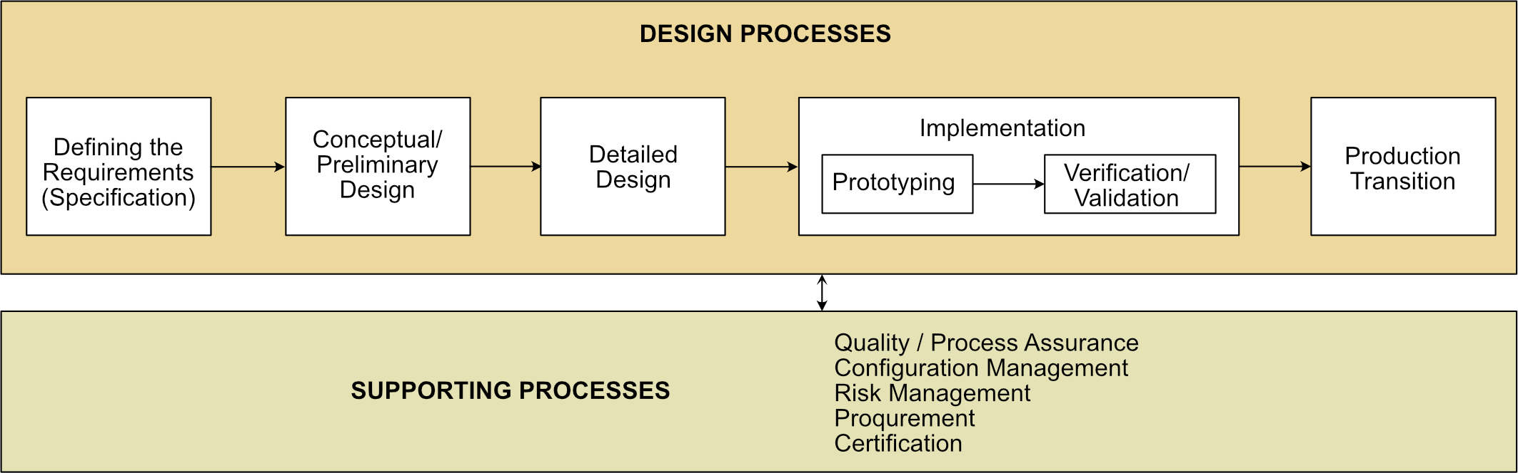
Figure 2: Design flow showing basic design activities
The Gantt chart given in Figure 3 shows the description and duration of tasks for scheduling. It has two main parts, a task list on the left side and a project timeline on the right.
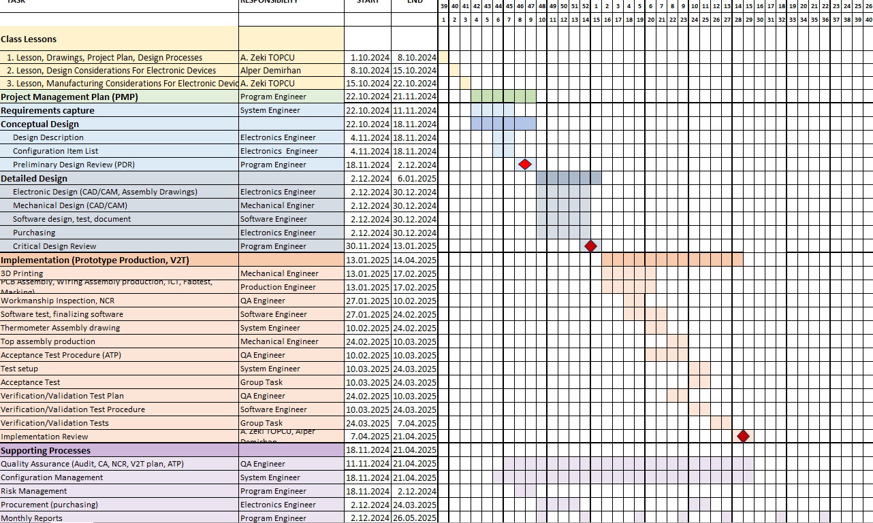Figure 3: Gannt Chart for Thermometer Project

